[10 different Number Pattern Programs in C#](https://www.csharpstar.com/10-different-number-pattern-programs-in-csharp/)

September 1, 2016 [4](https://www.csharpstar.com/10-different-number-pattern-programs-in-csharp/#comments)

[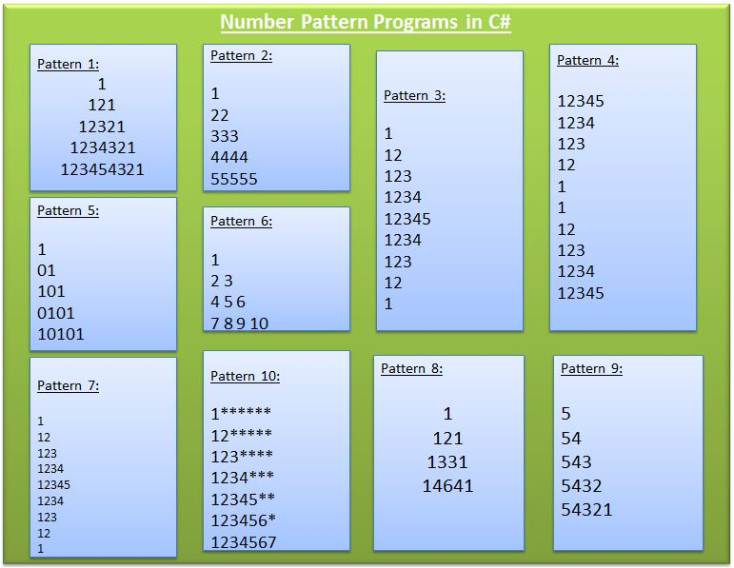](https://www.csharpstar.com/wp-content/uploads/2016/09/NumberPattern_csharp.jpg?2d1e51&2d1e51)

Pattern 1:

[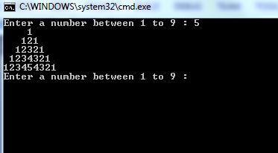](https://www.csharpstar.com/wp-content/uploads/2016/09/Num_pattern1.jpg?2d1e51&2d1e51)

class pyramid

{

    public static void Main()

    {

        int num, space;

        while (true)

        {

            Console.Write("Enter a number between 1 to 9 : ");

            num = Convert.ToInt32(Console.ReadLine());

            space = num - 1;

            for (int i = 1; i <= num; i++)

            {

                for (space = 1; space <= (num - i); space++)

                {

                    Console.Write(" ");

                }

                for (int j = 1; j <= i; j++)

                {

                    Console.Write(j);

                }

                for (int k = (i - 1); k >= 1; k--)

                {

                    Console.Write(k);

                }

                Console.WriteLine();

            }

        }

    }

}

Try now in dotnetfiddle [here](https://dotnetfiddle.net/qn59Ej).

Pattern:2

1  
22  
333  
4444  
55555

class NumberPattern

{

    public static void Main()

    {

        int no = 5;

        for (int i = 1; i <= 5; i++)

        {

            for (int j = 1; j <= i; j++)

            {

                Console.Write(i);

            }

            Console.WriteLine();

        }

        Console.ReadKey();

    }

}

Pattern:3

1  
12  
123  
1234  
12345  
1234  
123  
12  
1

You can try this pattern online [here](https://dotnetfiddle.net/TpYvLY).

class Program

    {

        public static void Main(string[] args)

        {

            Console.Write("Enter a number: ");

            int n = Convert.ToInt32(Console.ReadLine());

            Console.WriteLine();

            for(int i = 1; i < n; i++)

            {

                for(int j = 1; j <= i; j++)

                    Console.Write(j.ToString());

                Console.WriteLine();

            }

            for(int i = n; i >= 0; i--)

            {

                for(int j = 1; j <= i; j++)

                    Console.Write(j.ToString());

                Console.WriteLine();

            }

            Console.WriteLine();

        }

    }

Pattern:4

12345  
1234  
123  
12  
1

1  
12  
123  
1234  
12345

class Program

    {

        public static void Main(string[] args)

        {

            Console.Write("Enter a number: ");

            int n = Convert.ToInt32(Console.ReadLine());

            Console.WriteLine();

            for (int i = n; i >= 0; i--)

            {

                for (int j = 1; j <= i; j++)

                    Console.Write(j.ToString());

                Console.WriteLine();

            }

            for(int i = 1; i <= n; i++)

            {

                for(int j = 1; j <= i; j++)

                    Console.Write(j.ToString());

                Console.WriteLine();

            }

            Console.WriteLine();

        }

    }

5. Pattern:5

1  
01  
101  
0101  
10101

class Program

{

    public static void Main(string[] args)

    {

        int i, j, n, p, q;

        Console.Write("\n\n");

        Console.Write("Print the Floyd's Triangle:\n");

        Console.Write("-----------------------------");

        Console.Write("\n\n");

        Console.Write("Input number of rows : ");

        n = Convert.ToInt32(Console.ReadLine());

        for (i = 1; i <= n; i++)

        {

            if (i % 2 == 0)

            { p = 1; q = 0; }

            else

            { p = 0; q = 1; }

            for (j = 1; j <= i; j++)

                if (j % 2 == 0)

                    Console.Write("{0}", p);

                else

                    Console.Write("{0}", q);

            Console.Write("\n");

        }

    }

}

Pattern: 6

1  
2 3  
4 5 6  
7 8 9 10

public static void Main(string[] args)

    {

        int i, j, rows, k = 1;

        Console.Write("\n\n");

        Console.Write("Display the pattern like right angle triangle with number increased by 1:\n");

        Console.Write("---------------------------------------------------------------------------");

        Console.Write("\n\n");

        Console.Write("Input number of rows : ");

        rows = Convert.ToInt32(Console.ReadLine());

        for (i = 1; i <= rows; i++)

        {

            for (j = 1; j <= i; j++)

                Console.Write("{0} ", k++);

            Console.Write("\n");

        }

    }

Pattern:7

1  
1 2  
1 2 3  
1 2 3 4  
1 2 3 4 5  
1 2 3 4  
1 2 3  
1 2  
1

class Program

{

    public static void Main(string[] args)

    {

        for (int i = 1; i <= 5; i++)

        {

            for (int j = 1; j <= i; j++)

            {

                Console.Write("" + (j));

            }

            Console.WriteLine("");

        }

        for (int k = 4; k >= 0; --k)

        {

            for (int j = 1; j <= k; j++)

            {

                Console.Write("" + (k));

            }

            Console.WriteLine("");

        }

    }

}

Pattern:8

[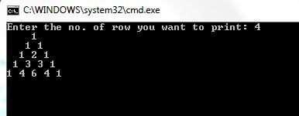](https://www.csharpstar.com/wp-content/uploads/2016/08/Num_pattern8.jpg?2d1e51&2d1e51)

public static void Main(string[] args)

    {

        int row, i, j, k;

        Console.Write("Enter the no. of row you want to print: ");

        row = Convert.ToInt32(Console.ReadLine());

        for (i = 0; i <= row; i++)

        {

            k = 1;

            for (j = i; j <= row - 1; j++)

                Console.Write(" ");

            for (j = 0; j <= i; j++)

            {

                Console.Write("{0} ", k);

                k = (k * (i - j) / (j + 1));

            }

            Console.WriteLine();

        }

        Console.ReadLine();

    }

Pattern 9:

5  
54  
543  
5432  
54321

public static void Main(string[] args)

    {

        {

            int i = 5;

            while (i >= 1)

            {

                int j = 5;

                while (j >= i)

                {

                    Console.Write(j);

                    j--;

                }

                i--;

                Console.WriteLine();

            }

            Console.Read();

        }

    }

Pattern:10

[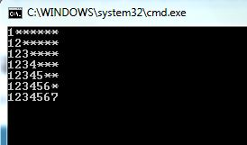](https://www.csharpstar.com/wp-content/uploads/2016/09/num_pattern10.jpg?2d1e51&2d1e51)

public static void Main(string[] args)

    {

        int i, j, k;

        for (i = 1; i <= 7; i++)

        {

            for (j = 1; j <= i; ++j)

                Console.Write(j);

            for (k = 7 - i; k >= 1; k--)

                Console.Write("*");

            Console.Write("\n");

        }

        Console.ReadLine();

    }

Thanks for Visiting !!